@Anniethevegascaterer
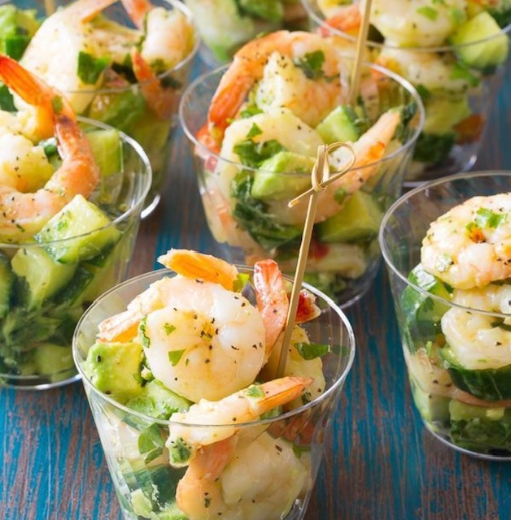
Annie’s Events /Annie’s Gourmet catering

Island Themed Dinner Buffet Menu

Cold Shrimp Cups with Cilantro Lime Dressing
Fresh Fruit Skewers
Cucumber Watermelon Salad with Blue Cheese
Organic Mixed Greens with Ranch and Balsamic
Sweet Rolls and Corn Bread with Honey and Butter
Teriyaki Chicken Kkewers
Beef, Onion and Pepper Skewers
Tropical island Rice
Sweet Corn
Balsamic Glazed Zucchini Grill
Baked Beans
Price Per Guest
$45Per Guest Plus Sales Tax and Set Up Fees

Event Policies
Reservations
Booking events require a 50% deposit of estimated billing to hold the date.
Proposals do not guarantee confirmed reservation for designated date unless a deposit and signed contract are in effect. Payment in full is due fourteen days prior to date. Billing is adjusted based on guest count at this time.
Food and Beverage Counts
The guaranteed number of guests is determined 14 days prior to event date. Should the actual number of guests exceed the guaranteed amount, the client will be charged for the difference on both food and beverage. Should the number of guests be less than the guaranteed amount, the client is still responsible for the guaranteed number of guests. All-inclusive packages are priced up to the designated guest amount. Any additional guests are charged at a per guest rate.
Beverage Services
Staff and Management of Annie's Events reserve the right to refuse service of alcoholic beverages to anyone appearing to be intoxicated, or anyone under 21 years of age.
Minimums
$2000 Food and Beverage Minimum Applies to all events. This is pretax and set up fees.
Additional fees are based on setup details and staffing requirements.
Client and caterer agree to all fees upon contract signing and before deposit is processed.
Cancellation Policy
Any cancellation must be received in writing. Deposits are nonrefundable.
An event date may be changed for no additional fee, based on availability.

Thank you for choosing Annie’s Events for your special occasion!
It is our pleasure to provide you with our professional services to ensure a successful outcome.
@Anniethevegascaterer

