Annie’s Gourmet Lunch Buffet:
Assorted rolls, artisan breads, butter, and olive tapenade

Choice of Salad:
Caesar
Chopped romaine, shaved parmesan, topped with homemade garlic croutons
Organic Mixed Greens
Topped with sliced beets, candied walnuts, dried cranberries,
and fried onion crispers, tossed in fig balsamic dressing
Tortellini
Pasta rounds with black beans, artichoke hearts cherry tomatoes and shredded cheddar, tossed in vidalia onion dressing
Trottole
Pasta spirals with roasted red peppers, kidney beans, cucumber, and mozzarella,
tossed in balsamic glaze
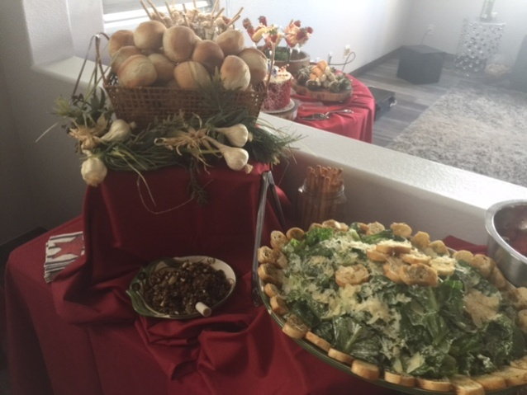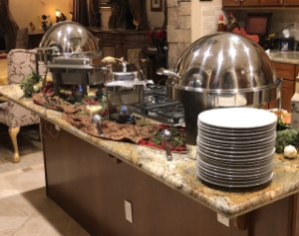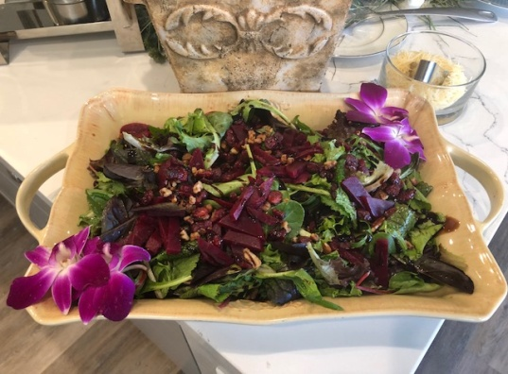
Choice of Two Entrees:
Chicken
Parmigiana- Breaded breast and sautéed, topped with three cheeses and baked
Marsala- Breasts sautéed in marsala wine and sliced white mushrooms
Mediterranean- Breasts sauteed in olive oil and fresh garlic,
topped with artichoke hearts and sun-dried tomatoes
Piccata- Breasts sauteed in white wine and lemon, topped with capers
Caprese- Breast rolled with Roma tomato, basil, and sliced mozzarella
Eggplant Parmigiana Fettucini Alfredo Sausage and Peppers
Baked Penne Lasagne Meatballs Parmigiana
Spaghetti with Meat Sauce Tortellini with Alfredo or Marinara

Choice of side
Garlic Whipped Mashed Potatoes Roasted Baby Red Potatoes
Penne Marinara Mushroom Risotto
Sauteed Asparagus Baby Carrots Squash Blend Roasted Brussels Sprouts

Dessert: Choice of One
Assorted Cookies or Mini Cannoli
$35 Per Guest Plus Tax and Delivery ** Setup Charge Required for Full-Service Events

